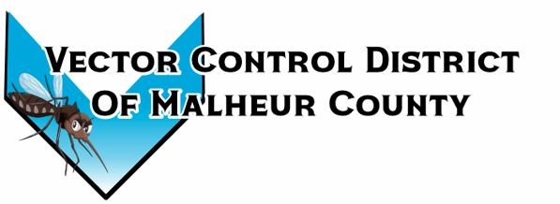Vector Control District of Malheur County
Mailing Address 454 12th St N Vale, Oregon 97918  Phone 541-709-7478  Email MCVCD23@outlook.com

Meeting Announcement!
Vector Control District of Malheur County
Wednesday June 5, 2024
5:30pm Mackey’s Public House
111 SW 1st St, Ontario, OR 97914

Agenda Items;
- Budget Hearing

- Previous meeting minutes

- Financial Report

- Operations Report

- Open Discussion

