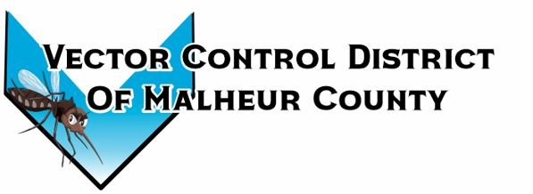Vector Control District of Malheur County Mailing Address 454 12th St N Vale, Oregon 97918  Phone 541-709-7478  Email MCVCD23@outlook.com

June 5, 2024
Attendance: Kelly Peterson, Megan Bernard, Jeremy Evers, Terry Oft, Mary Jo Evers, Dave Bunker
Terry opens budget hearing at 5:49pm, budget hearing closes at 6:00pm with no public comments.
Kelly motions to approve previous meeting minutes Jeremey seconds passed unanimously.
Financial Report:
Checking $41,558.23 LGIP: $376,912.32 Mary Jo informed the board the audit review draft and will be available at the next meeting. The board members look through monthly expenses and signed checks.
Operation Report:
Both tire collections are completed for the season. Juntura and Jordan Valley have been treated. Next round of treatments for the other ponds has started. Megan fogged Juntura on May 30th in preparation for the Bentz’s horse sale where 500-700 people are expected to be in attendance. Barrier spray notices have been hung around the Nyssa rodeo grounds and is set for June 11th. The bi-weekly meeting for the Oregon Mosquito and Vector Control Association (OMVCA) has started. This week the district was not able to set traps due to shortage of dry ice at Tour Ice of Ontario. Megan informed the board that she has a credit application from a company over in Nampa, ID called Oxarc. Oxarc is the place that Idaho counties get their dry ice. Oxarc can deliver or the district can go pick it up. Canyon County, ID has theirs delivered and they get approximately 500lbs a week, but they set a lot more traps then Malheur does. The board asked Megan to look into a dry ice freezer and how long approximately the ice would last in said freezer. As of May 30th, 62 traps have been set and 123 Culex have been collected and tested. Compared to last year at this time the district is up 42 traps and down 82 Culex. Megan has contacted the leaf cutter bee company and has a meeting scheduled to make sure the district has the correct locations of the hives.
Kelly motions to approve resolution 24-1 and 24-2 Jeremy seconds passed unanimously.
Next meeting is set for July 11th at 2:30pm at the Plaza Inn in Ontario, Oregon
Meeting adjourned at 6:50pm
Minutes recorded by District Manager

