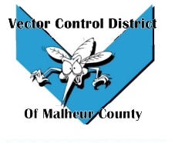Vector Control District of Malheur County Mailing Address 454 12th St N Vale, Oregon 97918  Phone 541-709-7478  Email MCVCD23@outlook.com

Meeting Announcement!
Vector Control District of Malheur County
Thursday May 4, 2023
6:00pm Matsy’s Restaurant
1241 SW 4th Ave, Ontario, OR 97914
Agenda Items;
- Previous meeting minutes

- Budget Committee Meeting

- Financial Report

- Operations Report

- Open Discussion

