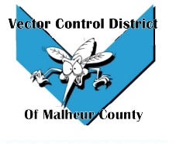Vector Control District of Malheur County Mailing Address 454 12th St N Vale, Oregon 97918  Phone 541-709-7478  Email MCVCD23@outlook.com

Meeting Announcement!
Vector Control District of Malheur County
Monday March 6, 2023
12:30 Plaza Inn Restaurant
812 SW 4th Ave #2627, Ontario, OR 97914
Agenda Items;
- Previous meeting minutes

- Financial Report

- Operations Report

- Executive Session
*per ORS 192(2)(i) to review and evaluate the employment-related performance of the chief executive officer of any public body, public officer, employee or staff member who does not request an open hearing
- Open Discussion

