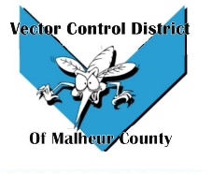Vector Control District of Malheur County Mailing Address 454 12th St N Vale, Oregon 97918  Phone 541-709-7478  Email MCVCD23@outlook.com

Meeting Announcement!
Vector Control District of Malheur County
Thursday June 8, 2023
12:30 Plaza Inn Restaurant
812 SW 4th Ave #2627, Ontario, OR 97914
Agenda Items;
- Previous meeting minutes

- Budget Hearing

- Financial Report

- Operations Report

- Open Discussion

