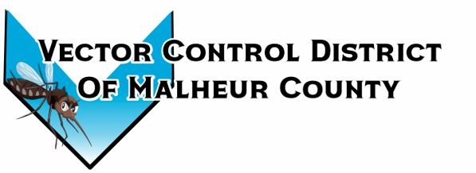Vector Control District of Malheur County Mailing Address 454 12th St N Vale, Oregon 97918  Phone 541-709-7478  Email MCVCD23@outlook.com

Meeting Announcement!
Vector Control District of Malheur County
Wednesday June 11, 2025
12:30pm Plaza Inn Restaurant
812 SW 4th Ave #2627, Ontario, Oregon 97914
Join Zoom Meeting
https://us05web.zoom.us/j/6658920760?pwd=WXNZdCtXcU50bDllWTl5VVVoN0VIdz09&omn=81317469217
Meeting ID: 665 892 0760 Passcode: 6zN8Rh
Agenda Items;

- Executive Session ORS 192.610(2) i
  - Will be held at 12:00pm prior to the board meeting

- Budget Hearing

- Previous meeting minutes

- Financial Report
  - Signing of monthly checks

- Operations Report

- Open Discussion

