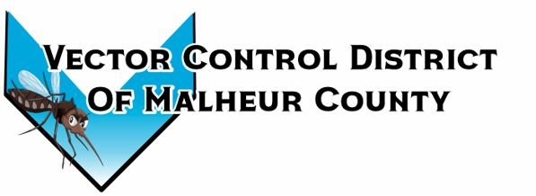Vector Control District of Malheur County Mailing Address 454 12th St N Vale, Oregon 97918  Phone 541-709-7478  Email MCVCD23@outlook.com

July 11, 2024
Attendance: Kelly Peterson, Megan Bernard, Jeremy Evers, Terry Oft, Mary Jo Evers, Ray Waldo, Jimmy Simpson
Board meeting opens 2:30pm
Kelly motions to approve previous meeting minutes Jimmy seconds passed unanimously.
Financial Report:
Checking $37,992.17 LGIP: $341,177.02 Mary Jo informed the board the audit review draft and will be available at the next meeting. The board members look through monthly expenses and signed checks. Mary Jo will have the audit at next meeting and walk the board through it.
Jimmy motions to approve monthly checks Jeremy seconds, passed unanimously.
Ray motions to approve financial report Kelly seconds, passed unanimously.
Kelly makes a motion to increase Mary Jo’s pay to $1,900 a month Ray seconds, passed unanimously.
Operation Report:
Fogging operations began on June 24th for the season. Vale park and rodeo were barrier sprayed in perpetration of the 4th of July festivities, buckets were also placed at each entrance of the rodeo. We have started split shifts due to the high temperatures, we will continue until the heat was goes away. July 9th the district detected its first West Nile positive pool located in Little Valley the samples have been sent to OSU for confirmation. The county health department has been notified, we have a press release ready to publish once we get confirmation. Total mosquitoes caught in 2024: 980 vs 23: 5,034 total Culex mosquitoes tested in 2024: 86 vs. 23: 63. First mosquito positive pool 2024: July 9th vs. 23: July 12th.
Board members increased the district managers pay by 5%
Next meeting is set for August 8th at 2:00pm at the Plaza Inn in Ontario, Oregon
Meeting adjourned at 3:55pm
Minutes recorded by District Manager

