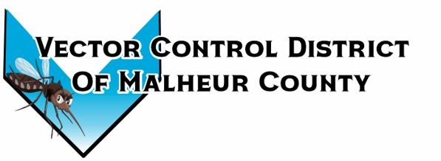Vector Control District of Malheur County Mailing Address 454 12th St N Vale, Oregon 97918  Phone 541-709-7478  Email MCVCD23@outlook.com

August 8, 2024
Attendance: Kelly Peterson, Megan Bernard, Jeremy Evers, Terry Oft, Mary Jo Evers, Ray Waldo
Board meeting opens 2:00pm
Kelly motions to approve previous meeting minutes, Jeremy seconds passed unanimously.
Financial Report:
Board members sign monthly checks.
Checking $46,353.76 LGIP $294,684.11
Mary Jo gives the board members the audit review for 2022-2023. Mary Jo goes through the review and explains it page by page. On page 6, it states the district received more funds than budgeted and spent less than budgeted. A copy of the audit review will be kept at the districts office.
Kelly motions to approve the audit review as written, Jeremy seconds passed unanimously.
Ray motions to approve monthly bills, Jeremy seconds passed unanimously.
Megan mentioned the broken concreate that is in front of the shop, she mentioned that is could be a potential tripping hazard due to the concreate broken and cracked in areas. The board members would like Megan to get quotes for redoing the concreate that is in front of the shop.
Operation Report:
This year the district was at the county fair and used the enclosed trailer to hang informational posters and informational pamphlets. Only a few community members stopped by the booth. The crew walked around passing out mosquito wipes instead of having buckets at the main gates. Also the crew is almost done with this round of larvicide treatment. Barrier spray applications are in full swing for the schools, they will be completed by next Tuesday. Total of three positive locations within Malheur County, four pools total. Little Valley, South of Vale and Jordan Valley. Total mosquitoes caught as of yesterday 9,343 compared to last year 11,216 which is down 1,873. Total Culex mosquitoes caught as of yesterday 2,354 compared to last year 3,008 which is down 663. Baker, Jackson, and Morrow county have positive mosquito pools. Canyon, Ada, Twin Falls, Bannock and Bingham are counties in Idaho that have detected West Nile in mosquito pools.
Next meeting is set for September 12, 2024 at Plaza Inn at 2pm
Meeting adjourned at 3:30pm
Minutes recorded by District Manager

