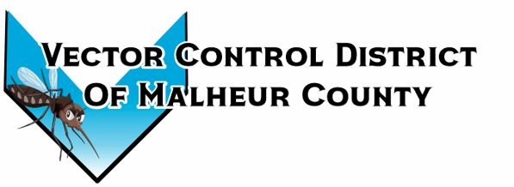Vector Control District of Malheur County Mailing Address 454 12th St N Vale, Oregon 97918  Phone 541-709-7478  Email MCVCD23@outlook.com
November 7, 2024, at 12:30pm Plaza Inn, Ontario, Oregon
Attendance: Terry Oft, Kelly Peterson, Jimmy Simpson, Jeremy Evers, Megan Bernard, Mary Jo Evers, Dave Bunker
Meeting opened at 12:36pm
Jimmy motions to approve previous meeting minutes, Jeremy seconds. Passed unanimously
Financial Report: Board members signed monthly checks. Checking: $14,074.71 LGIP: $254,950.24 Mary Jo informs the board members that the quarterly report is completed. Mary Jo also points out that the Vale City water bill is high due to last month’s check not being received by the City of Vale. So, Mary Jo canceled the previous month’s check and combined the two.
Kelly motions to approves the financial report Jimmy seconds, passed unanimously
Operations Report: Megan attended the Northwest Mosquito and Vector Control Association Conference in Leavenworth, WA on October 22nd and 23rd. There was a session regarding the Ades agypti (Zika virus) mosquito that was discovered in Jackson County, Oregon this past season. Jackson County did not do any adult control due to the virus not detected. The county crews did go out and speak with the public by going door to door handing out information regarding the discovery, they also did land surveys due to this species of mosquito being a container mosquito. There were other sessions that spoke about having enough information for the public to understand the need for our services. Megan also spoke with the Ontario Auto Ranch on the 28th of October regarding the recall on the new pickup. They told her to check back in a month because as of right now they do not have any fixes for said recall. Megan informs the board that information given she will take her personal vehicle to Coos Bay for the Oregon Mosquito and Vector Control Association meeting that is being held the week of November 11th-14th. With travel needed on the 11th of November the board has agreed to exchange days off for working Veterans Day. The shop will be closed on the Tuesday of Thanksgiving week. Megan spoke with Kim Speelman and Ellen Martinez with Field Waldo to look into the insurance on the drone. Jeremy mentions there is a separate policy for the drone through Liberty Mutual that is $500 a year for coverage. The board discussed if the drone should be taken off of insurance due to it not being used.
Kelly motions to approve .67 per mile for conference reimbursement for Megan using personal vehicle Jeremy seconds, passed unanimously. Vale to Leavenworth, WA and back 800 miles
Next meeting is set for January 9, 2025, at 12:30pm at the Plaza Inn Ontario, Oregon 97914
Executive session will take place at 12:00pm at the Plaza Inn prior to scheduled board meeting ORS 192.6.60 (2) I
Meeting adjourned at 1:48pm

