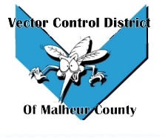Vector Control District of Malheur County Mailing Address 454 12th St N Vale, Oregon 97918  Phone 541-709-7478  Email MCVCD23@outlook.com

Attendance: Terry Oft, Ray Waldo, Kelly Peterson, Jeremy Evers, Jimmy Simpson, Mary Jo Evers, Megan Bernard, Lerry Wilson, Lee Newman, Tyler Simpson

Jimmy Motions to approve pervious meeting minutes Kelly seconds passes unanimously.

Financial Report:
Current amount in the checking $12,272.83 and current amount in the LGIP $372,485.48 with an interest rate of 3.75%. The board members signed monthly checks and went through the check detail.

Operations Report:

Megan informed the board that trapping will start May 10th Mary in Jordan Valley will start the 15th. Treatments down in Jordan are set for the 16th. The 18th Megan is taking the crew to the IMVCA meeting in Twin Falls, Idaho for credit towards their license. Big loop rodeo is coming up in Jordan Valley also, we will be providing mosquito wipes for people in attendance.

Next board meeting will be held on June 8th at 12:30 at the Plaza Inn in Ontario, Oregon. That will coincide with the vector budget hearing

Meeting adjourned 7:12pm

