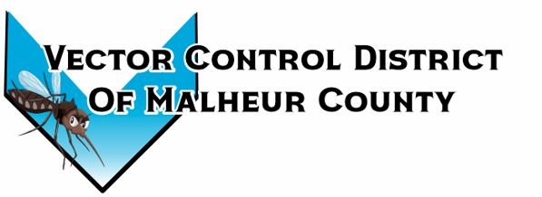Vector Control District of Malheur County Mailing Address 454 12th St N Vale, Oregon 97918  Phone 541-709-7478  Email MCVCD23@outlook.com

September 12, 2024 2pm Plaza Inn, Ontario, Oregon
Attendance: Terry Oft, Jeremy Evers, Jimmy Simpson, Ray Waldo, Mary Jo Evers, Dave Bunker, Megan Bernard
Meeting opened at 2:00 pm
Financial Report:
Board members signed monthly checks.
Checking: $25,914.19 LGIP: $257,597.78
Mary Jo will drop off this year’s audit to Judy.
Terry motions to pay this month’s bills Jimmy seconds, passed unanimously.
Operations Report:
Last round of treatments is happening now; Branch will start either tomorrow or Monday. This is Mary’s last week fogging due to the nightly temperatures and drop in mosquito counts. She will be trapping next week and the 23rd is her last day for the season. Next week is the last week for fogging for the rest of the crew. The week of the 23rd is the last week of the season, we will trap to get a final mosquito count for the season. The 26th is Karla and Katherine’s last day of the season. As of today we have caught 2,789 Culex mosquitoes and 11,202 total mosquitoes. Also, Jackson County has discovered Ades aegypti in Talent, Oregon in July. This is the first detection of Ades aegypti in Oregon. It was discovered in Shasta County, California in 2020 and Los Angeles County in 2011. This species of mosquitoes is starting to make their way up the West Coast. The mosquitoes were sent to lab to get genetically identified. This species of mosquitoes can only fly up to 500-feet. So, it is believed to be brought in from somewhere else and by getting them genetically identified the origin can be narrowed down. Megan will get more information during the fall state meeting. The board asked Megan about the weed situation at the shop, Megan informed the board that Jeff Mendiola came with a brush hog and mowed down the weeds. Ray motions to give a $200 Visa gift card to Jeff Mendiola for mowing down the weeds in the Vector yard, Jimmy seconds passed unanimously.
Next meeting is set for October 10, 2024 at 12:30pm at the Plaza Inn Ontario, Oregon 97914
Meeting ajurned at 2:52pm
Minutes taken by Megan Bernard, District Manager.

