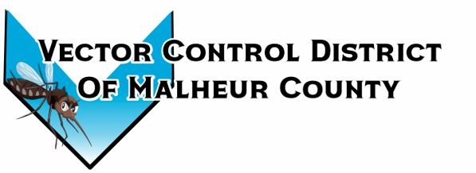Vector Control District of Malheur County Mailing Address 454 12th St N Vale, Oregon 97918  Phone 541-709-7478  Email MCVCD23@outlook.com
May 9, 2024
Attendance: Kelly Peterson, Jeremey Evers, Mike Miller, Larry White, Terry Oft, Ray Waldo, Jimmy Simpson, Tyler Simpson, Larry Wilson, Mary Jo Evers, Megan Bernard
Meeting Opened 5:10pm
Kelly motions to approve previous meeting minutes Jeremey seconds passed unanimously.
Financial Report:
Checking: $22,237.27 LGIP: $407,977.27 Mary Jo informs the board that Branch Enterprise is not in this check run. The board looks over monthly expenses. Ray motions to approve monthly bills Kelly seconds passed unanimously.
Operations Report:
The district held its first tire collection of the season in Ontario at the fairgrounds on the 19th of April, there the district collected 90+ tires. The next tire collection will be on May 10th. The district was also a part of Owyhee Field Days in Homedale, ID, the districts crew spoke with over 150 students from Oregon and Idaho schools. On May 8th all the foggers were calibrated and ready for the season. Owyhee Sign and Design gave Megan a quote of $750 for a 4ft x8ft sign for the front of the shop.
Kelly motions to purchase the new sign for the shop for $750 Kelly seconds, passed unanimously
Open Discussion:
The board members asked Megan to check when each of their terms are up. Ray Waldo 2027 Terry Oft 2025 Kelly Peterson 2026, Jimmy Simpson 2024, Jeremy Evers 2024. Jimmy and Jeremys terms are up this fall. The board members also asked Megan to look into the variable flow monitors for the foggers, Megan is going to ask her point of contact with Azelis regarding trial before purchasing.
Next meeting is set for June 5th at 5:30 located at Mackey’s Public House. Budget hearing will coincide with this meeting as well.
Meeting closed at 6:37
Minutes taken by: District Manager.

